SUPERSTORE DATABASE ANALYSIS

SQL Capstone Project Report

A structured analysis of suppliers, customers, products, and orders

1. EXECUTIVE SUMMARY

This report presents a structured analysis of the Superstore_DB relational database using 20 SQL queries written in T-SQL (Microsoft SQL Server). The analysis covers four core business areas: customers, suppliers, products, and orders.

The objective was to extract actionable business insights by applying a wide range of SQL techniques including filtering, joining multiple tables, aggregating data, conditional logic with CASE statements, and pattern matching. Each query was written with optimisation in mind, using targeted column selection, table aliases, and appropriate aggregate functions to ensure accuracy and performance.

Key findings include strong customer concentration in the USA, significant supplier variation by country, product availability insights for inventory management, and sales performance data that can inform future marketing and loyalty strategies.

2. DATABASE OVERVIEW

The Superstore_DB database was created in Microsoft SQL Server and populated with data imported from a CSV file. The database contains 5 related tables that together represent a complete retail business operation:

Table | Contents
Customer | Customer details - name, city, country, phone
Supplier | Supplier details - company name, country
Product | Product details - name, unit price, package, supplier link
Order | Order header - order number, date, total amount, customer link
OrderItem | Order line items - product, quantity, unit price, order link

The tables are linked through foreign key relationships — for example, Order references Customer via CustomerId, and OrderItem references both Order and Product. This relational structure enabled multi-table JOIN queries to combine data across business functions.

2.1 Data Quality Checks Performed

• Checked all 24 columns for NULL values - no missing data was found across any column

• Checked for duplicate records using the Row ID primary key - no duplicates were identified

• Data was confirmed clean and consistent before analysis began

Data Quality: The dataset passed all NULL and duplicate checks - confirming it is clean, complete, and ready for reliable analysis.

3. SQL TECHNIQUES USED

The following SQL techniques were applied across the 20 queries. Each technique was chosen to solve a specific analytical question efficiently:

SQL Technique | Description
SELECT / WHERE | Filter and retrieve specific rows or columns from a table
ORDER BY | Sort results in ascending (ASC) or descending (DESC) order
INNER JOIN | Combine rows from two or more tables based on a related column
GROUP BY | Aggregate data by grouping rows that share a common value
HAVING | Filter aggregated results — used after GROUP BY
COUNT / SUM / AVG | Aggregate functions to count rows, sum values, or calculate averages
CASE Statement | Apply conditional logic to return different values based on conditions
LIKE | Pattern matching to filter text data (e.g. starts with 'Ca')
DISTINCT | Remove duplicate rows from query results
Concatenation | Combine two or more columns into a single formatted output

All queries were written with performance optimisation in mind. SELECT * was avoided where possible, column aliases were used for readability, and HAVING was used instead of WHERE when filtering aggregated results.

4. QUERY REFERENCE TABLE

The table below provides a complete reference of all 20 queries, the key SQL technique used, and the business purpose each query serves:

No. | Query Description | Key Technique | Business Use
Q1 | Suppliers in the UK | WHERE | Vendor management
Q2 | Customer full name and city (concatenated) | SELECT, Concat | Personalised engagement
Q3 | Customers in Sweden | WHERE | Country-specific marketing
Q4 | Suppliers in alphabetical order | ORDER BY ASC | Procurement reference
Q5 | Suppliers with their products | INNER JOIN | Supply chain tracking
Q6 | Orders with customer information | INNER JOIN | Customer service
Q7 | Orders with product, quantity, price | Multiple JOINs | Sales transparency
Q8 | Product availability status | CASE Statement | Inventory management
Q9 | Supplier country to language mapping | CASE, DISTINCT | Communication planning
Q10 | Products packaged in Jars | WHERE, LIKE | Packaging promotions
Q11 | Products starting with 'Ca' | LIKE 'Ca%' | Catalog lookup
Q12 | Number of products per supplier | COUNT, GROUP BY | Supplier evaluation
Q13 | Customer count by country | COUNT, GROUP BY | Market presence
Q14 | Customer count by country (high to low) | ORDER BY DESC | Expansion focus
Q15 | Total order amount per customer | SUM, GROUP BY | Loyalty programs
Q16 | Countries with more than 2 suppliers | HAVING COUNT > 2 | Sourcing strength
Q17 | Countries with more than 10 customers | HAVING COUNT > 10 | Growth markets
Q18 | Top countries excl. USA (9+ customers) | WHERE, HAVING | International focus
Q19 | Customers with avg order $1,000–$1,200 | AVG, HAVING BETWEEN | Upsell targeting
Q20 | Orders and revenue — January 2013 | COUNT, SUM, WHERE | Sales benchmarking

Customer Insights
Customers are distributed across multiple countries. Queries highlighted both total customer counts (Q13, Q14) and which countries have more than 10 or 9 customers (Q17, Q18).
The USA has the highest customer base, but excluding it shows other strong international markets.
Customers in Sweden and the UK can be specifically identified for targeted campaigns.
Customer details such as full name and city (Q2) enable more personalized engagement.
Identifying customers with average order sizes between $1000–$1200 (Q19) reveals a mid-range spending group that can be nurtured for upselling opportunities.
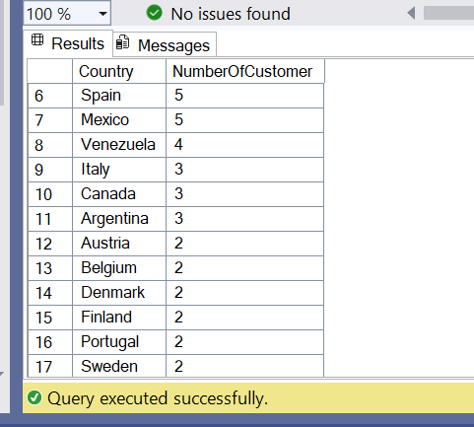

Supplier Insights
Suppliers in the UK (Q1) can be isolated for local vendor management.
A complete alphabetical list of suppliers (Q4) provides an easy reference point for procurement teams.
Linking suppliers to their products (Q5) strengthens supply chain visibility.
Countries with more than 2 suppliers (Q16) represent stronger sourcing options.
Supplier countries can be linked to their likely spoken languages (Q9), which is useful for communication and negotiation.
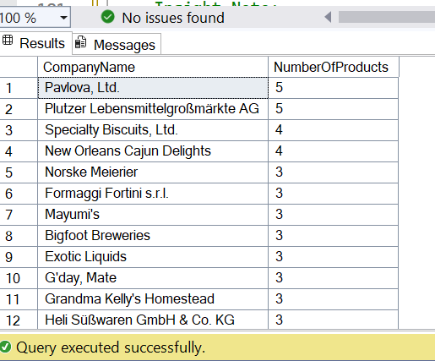

Product Insights
Products packaged in jars (Q10) can be isolated for packaging-specific promotions or bundle strategies.
Products starting with “Ca” (Q11) can be quickly searched for catalog or marketing purposes.
Using CASE statements (Q8), products were categorized into Available and Not Available, making it easier to monitor stock status.
The number of products per supplier (Q12) highlights which vendors offer the broadest range—important for risk management and supplier evaluation.
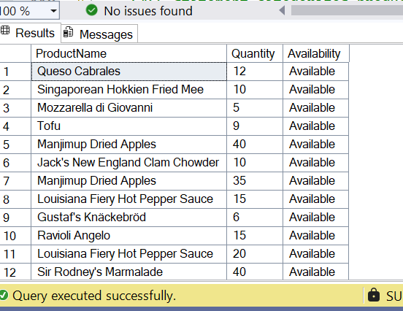

Order & Sales Insights
Orders linked to customer information (Q6) allow a full view of buyer demographics, location, and purchase history.
Orders linked to product details (Q7) provide transparency into what was sold, in what quantity, and at what price.
Total order amounts per customer (Q15) identify the top-spending customers, which is valuable for loyalty programs and targeted offers.
Sales analysis for January 2013 (Q20) provided both total orders and total revenue, serving as a performance benchmark.
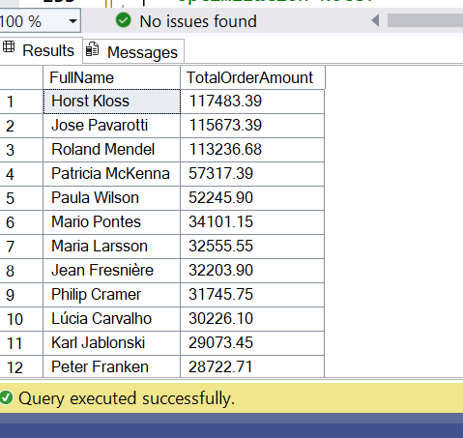

Key Business Takeaways
- Customer Base : Strong presence in the USA, with Sweden and the UK standing out as other key markets.
- Suppliers : Concentrated in some countries; top suppliers contribute significantly more products than others.
- Products : Stock availability and packaging-based filtering provide useful levers for marketing and operations.
- Sales: January 2013 sales data offers insights into seasonal performance, while customer spending patterns reveal valuable mid-range and top-tier buyers.
